Independent Living Center of Kern County Annual Report
2021 - 2022

Empowering individuals with disabilities to live as
independently as possible - Since 1981

Consumer Demographics

2 % American Indian, Alaskan Native
1 % Asian
17 % Black / African American
> 1 % Native Hawaiian, Pacific Islander

41 % White
32 % Hispanic / Latino
5 % Two or more ethnicities
> 1 % Ethnicity unknown

According to consumer feedback:

87 % found the services useful.
100 % of staff have been kind, sensitive, and courteous.
87 % of staff were knowledgeable.
75 % felt encouraged to develop their Independent Living Plan.
63 % felt their needs were met.
63 % felt their overall quality of life has improved.
75 % felt that calls were returned promptly.
75 % agree staff encouraged them to do things on their own.
100 % were overall satisfied with services.

Service Category Totals

Advocacy - 69
Personal Assistance - 61
Vocational - 11
Assistive Technology - 170
Communication - 47
Transportation - 16
Mobility Training - 17

Recreational - 2
Youth and Transition - 4
Information & Referral - 372
Independent Living Skills Training - 307
Preventative - 63
Housing and Related Services - 276
Peer Counseling - 63

Total individual services offered in 2021 - 2022 = 1,522

Federal Funding
SSA, ACL
Grants
ILC CARES Act, ADRC CARES Act, DOR/OIB Contract, Pacific DBTAC – ADA, CA Emerging
Technology Fund, Housing Authority of Kern County , Department of Health Care Services, Pacific Gas and Electric / SoCal Edison, State of California Dept. of Aging / ADRC, Kern County Office of Emergency Services, Kern County Department of General Services, The SCAN Foundation

Disability Types Assisted

Cognitive 22
Mental Health 92
Physical 160
Hearing 5

Vision 74
Multiple 78
Other 0
Total 431

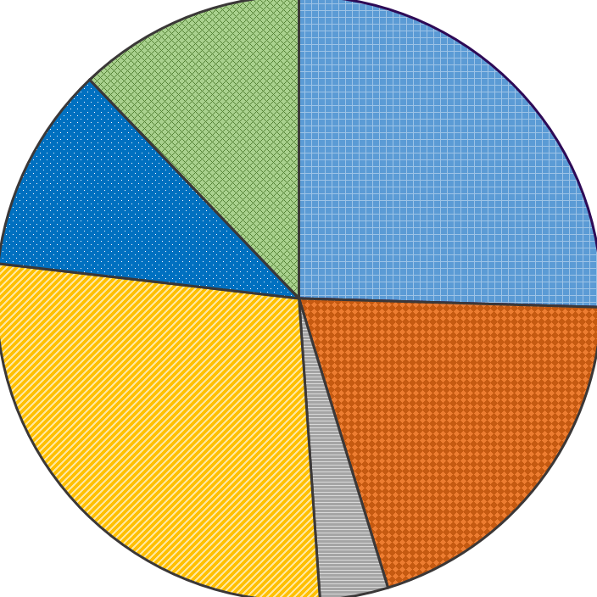
2021 – 2022 Fiscal Year Expenses
11 % Fee-for-Service Programs
28 % ADRC & ADRC COVID-19
4 % Older Individuals who are Blind
20 % Independent Living Center AB 204
25 % Independent Living Center
12 % Other Programs
Figure 1: Pie chart with sections according
to the percentages listed aside chart.

Kern County
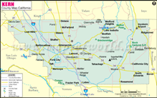
Figure 2: Kern County map
- ILCKC serves all 8,163 miles of Kern County
- 100% of every dollar donated stays in Kern County

63% of ILCKC Board Members live with a Significant Disability.
56% of ILCKC Staff live with a Significant Disability.
272 Active Consumers + 159 New Consumers = 431 Total Consumers

Empowerment
Our vision is to promote positive change in society leading to the integration and acceptance of persons with disabilities within our community.

Friends of ILCKC

In-kind donations and financial support is always appreciated!
Figure 3: Screenshot of the online donation platform. Alt text: “’Donate to Independent Living Center of Kern County’ with QR code that leads to donation page. ‘Make this a monthly donation’ is selected with floating heart icons above selection. Two button options:
(1) Donate with PayPal (2) Donate with Debit or Credit Card”
Independent Living Center of Kern County
5251 Office Park Drive, Suite 200
Bakersfield, CA 93309
(661) 325 - 1063
www.ilcofkerncounty.org

End document

